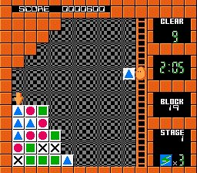
EVALUATION OF
THE WHOLE
PROGRAM
Figure 9: Conceptual Framework for the Cubies A 2D Mobile Game

Information From
Books
Journals
Electronic sources
Internet
Technology
Hardware
Mobile phone
Personal Computer
Software
Java
J2ME
Image Editor

To design a mobile game for colored mobile phones.
To develop a game program for mobile phones.
To test and implement the game program.
INPUT
PROCESS
OUTPUT

